Create a mini-unit of three lessons to teach the content area standard you chose for the assignment in Topic 5.
Incorporate a variety of instructional strategies and implement activities that address the students’ individual learning needs.
Create a pre-assessment and at least one formative assessment that would help determine the learning needs of your students.
Create a summative assessment and a standards-based rubric to be given at the end of the mini-unit. Your assessments must align to your objectives.
Submit the lesson plans, assessments, and rubric to your instructor as one deliverable.
APA format is not required for this assignment, but solid academic writing is expected.

I am so impressed, I don’t even know what to say. You brought in so many resources to tap into all the learning styles. I encourage you to keep this unit plan as you can even extend in the future. If I were the substitute, I could easily follow with all the details you provided for each step of the day. I’m looking forward to seeing what you will add for week 7 Benchmark.
Cindy

Section 1: Lesson Preparation 1

Teacher Candidate Name:
Grade Level: | 8th
Date: | March 6, 2019
Unit/Subject: | Geometric Transformations
Instructional Plan Title: | Introduction to Transformations
Lesson Summary and Focus: | Students will be introduced to the four types of transformations, dilation, translation, reflection and rotation, with emphasis on the later. At the end of the lesson students will be asked to label an example of a translation, rotation and reflection.
Classroom and Student Factors/Grouping: | Preferential seating (see seating chart)  Extended time or shortened assignments (see assignment schedule) Group work (see grouping list and job chart)  Monitor students’ individual work frequently (see assignment schedule)
National/State Learning Standards: | Alabama Course of Study Mathematics Standards:  Verify experimentally the properties of rotations, reflections, and translations: [8- G1]  a. Lines are taken to lines, and line segments are taken to line segments of the same length. [8-G1a]

- Angles are taken to angles of the same measure. [8-G1b]

- Parallel lines are taken to parallel lines. [8-G1c]
Specific Learning Target(s)/Objectives: Excellent job your measurable objectives. | Students will label examples of transformations as either translation, reflection or rotation with 50% accuracy.  Students will create a list with at least 3 items of general properties of translation, rotation, dilation and reflection.
Academic Language | Students will watch a video of real-world examples of translations, reflections, rotations, and dilations. They will write down their observations on the notes of their choice.  Geometric Transformations Translations  Reflection Rotation Dilation Congruent
Resources, Materials, Equipment, and Technology: | ELMO  Laptop Projector Whiteboard  Markers/ Colored pencils  Youtube- “Jalen’s Transformations in Real Life” Cha Cha Slide Lyrics  Transformation Study Chart  Transformation Mini Poster

Section 2: Instructional Planning

Anticipatory Set  - I will have the students perform a 30 sec write around to pre-assess any prior knowledge about geometric transformations. Good job thinking of the pre-test first.  - Next, students will move the desks to the sides of the room to clear a space for them to perform the Cha Cha Slide by DJ Casper. | Time Needed
Multiple Means of Representation  - Students will be given the option to use either the Transformation Study Chart or Transformation Mini Poster or both to write down their observations from the YouTube video “Jalen’s Transformations in Real Life.”  - During the video, I will use the PAWS, Think and Share strategy to pause the video after each transformation example and ask if they would like to see that again and then ask if anyone would like to share something they noticed about that transformation.  Explain how you will differentiate materials for each of the following groups:  - English language learners (ELL):  - Students with special needs:  Allow all students to choose between note options and make sure they understand what is expected on each option or give them an example to follow. Also, monitor their notes for correct information.  - Students with gifted abilities:  - Early finishers (those students who finish early and may need additional resources/support): | Time Needed
Multiple Means of Engagement  - After the video, I will tell students they have performed transformations before with their previous lessons and today.  - I will make sure students are writing examples on their note form of choice from the video or our discussion. Additionally, through questioning or explicit instruction students will see a connection between graphing a line and translation and dilation and proportions and ratios. | Time Needed

- Lastly, we will discuss that they performed transformations when they were dancing.

Explain how you will differentiate activities for each of the following groups:
- English language learners (ELL):

- Students with special needs:
Monitor students body language and facial expressions for confusion. Walk around and monitor notes for correct information.

- Students with gifted abilities:

- Early finishers (those students who finish early and may need additional resources/support):
Multiple Means of Expression  Students will use a print out of the Cha Cha Slide lyrics to color the lyrics which represent a translation, rotation or reflection. One color per transformation. In the last few minutes of class, I will have volunteers use the ELMO to give us a graphed line, angle or point and either ask the class to transform it or perform a transformation on it and have the class guess what it is.  Explain if you will differentiate assessments for each of the following groups:  - English language learners (ELL):  - Students with special needs:  Students will be allowed to use their notes to help them label the lyrics.  - Students with gifted abilities:  - Early finishers (those students who finish early and may need additional resources/support): | Time Needed

Extension Activity and/or Homework  Students will be asked to come into class with a picture, physical example, or description of at least one transformation we covered during todays lesson. | Time Needed
Rationale/Reflection
- PAWS, Think, Share promotes critical thinking, communication and collaboration. Students are expected to reflect on the question and video before writing down their observations or answers and then share what they wrote with the class.
- Jot Notes promote creativity and critical thinking because students will notice different characteristics but will need to form those into a note.
- Student lead practice promotes communication, creativity, collaboration and critical thinking. With the use of the ELMO, students are furthering their understanding of technology use and creating their own problems.

Cha Cha Slide By Dj Casper

This time we're gonna get funky
Everybody clap your hands Clap clap clap clap your hands Clap clap clap clap your hands

Alright we gonna do the basic steps Slide to the left
Slide to the right Take it back now y'all One hop this time Right foot let's stomp Left foot let's stomp Cha cha real smooth
Now turn it out To the left
Take it back now y'all
One hop this time Right foot let's stomp

Left foot let's stomp Cha cha now y'all
Now it's time to get funky To the right
To the left
Take it back now y'all
One hop this time, one hop this time Right foot two stomps
Left foot two stomps Slide to the left
Slide to the right Criss cross, criss cross Cha cha real smooth
Lets go to work

To the left
Take it back now y'all
Two hops this time, two hops this time Right foot two stomps

Color and Create with Key Terms

Transformations

Directions: Illustrate your mini poster with the terms below. Cross each one off as you use it. All items must be used. Make sure each section of the page is a different type of transformation! Add color to receive maximum points!
Transformations (put in the center oval) Translation and its definition
Rotation and its definition Reflection and its definition Dilation and its definition Enlargement
Reduction

Rule for Reflection on y-axis Rule for Reflection on x-axis Scale Factor
Rule for 90° clockwise rotation

Rule for 90° counterclockwise rotation Rule for 180° rotation
Congruent figures Similar figures
(x, y) → (x + 4, y – 2)
Add your own:

© Anna Taylor http://www.teacherspayteachers.com/Store/Piece-Of-Pi

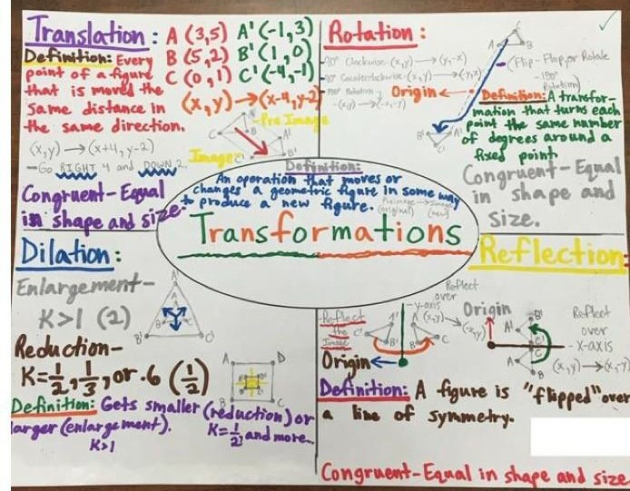

Thank you for visiting my store, Piece of Pi!

Please leave feedback on this product and let me
know how you used it with your students.

Follow my store to learn about my newest products and
promotions – just click the green star next to my store
name. Voila…you’re a follower!

https://www.teacherspayteachers.com/Store/Piece-Of-Pi

Check out more of my transformations resources – all used successfully
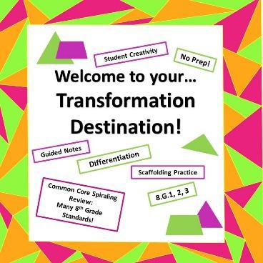
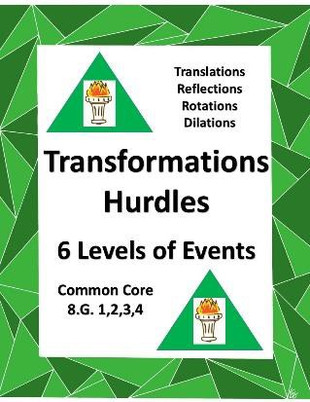
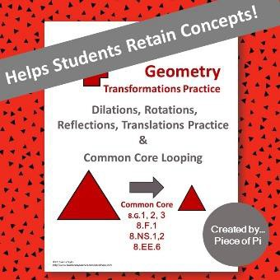
with my own 8th-graders!

© Anna Taylor http://www.teacherspayteachers.com/Store/Piece-Of-Pi

Type of Transformation | Direction(s)  of the change | How does the  x-Coordinate change? | How does the  y-coordinate change? | Example | Illustration
Translation
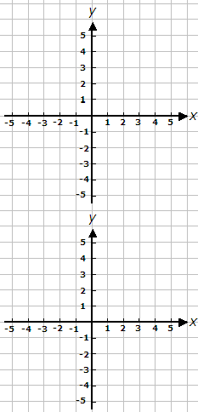

Type of Transformation | Direction(s)  of the change | How does the  x-Coordinate change? | How does the  y-coordinate change? | Example | Illustration
Reflection

Type of Transformation | Direction(s)  of the change | How does the  x-Coordinate change? | How does the  y-coordinate change? | Example | Illustration
Rotation | 90 degrees
 | 180 degrees | It changed to the opposite | It changed to the opposite | For example: Point A (4,5)  Rotated 180 degrees  A’ (-4, -5)

Section 1: Lesson Preparation 2

Teacher Candidate Name:
Grade Level: | 8th grade
Date: | March 7, 2019
Unit/Subject: | Geometric Transformations
Instructional Plan Title: | Practice Translation and Reflection
Lesson Summary and Focus: | Students will be refining their definitions and examples of translations, reflections, rotation and dilation, with emphasis on the first three. As well as practicing transformations on coordinates.
Classroom and Student Factors/Grouping: | Preferential seating (see seating chart)  Extended time or shortened assignments (see assignment schedule) Group work (see grouping list and job chart)  Monitor students’ individual work frequently (see assignment schedule)
National/State Learning Standards: | Alabama Course of Study Mathematics Standards:  Describe the effect of dilations, translations, rotations, and reflections on two- dimensional figures using coordinates. [8-G3]

Specific Learning Target(s)/Objectives: | Students will compare and contrast translation, rotation and reflection by reflecting on their previous assessment with 90% accuracy.  Students will perform translations and reflections on coordinates with 85% accuracy.
Academic Language | Students will watch a different YouTube video “Transformation song,” and will write down any new or different information they gain from the video. Too much fun!!  Geometric Transformation Translation  Rotation Reflection Dilation
Resources, Materials, Equipment, and Technology: | Cha Cha Lyrics Study guide/ notes White board Projector  Laptop  YouTube “Transformation Song” Transformation Study Chart Transformation Mini Poster Translation Coordinate Grid Transformation Practice Quiz

Section 2: Instructional Planning

Anticipatory Set  - Students will take out previous days study chart or poster, whichever they chose, to add more information from watching the YouTube video “Transformation Song.”  - Students will be asked to share what information they have added from the video and their examples from the homework assignment.  - Last, I will explain to students how a translation does not change the direction the object or figure is facing when it slides and explain this by saying how when you change seats in a movie theater, you don’t stop looking at the screen. | Time Needed
Multiple Means of Representation  - I will draw an X and Y axis on the whiteboard and ask for a volunteer to come label the quadrants, students will be asked thumbs-up, middle or down to show if they agree or not.  - Then I will draw names of students to come to the board and give an example of a coordinate in each quadrant, and they will have to answer other questions such as: How did you change the original point to this point, did the X or Y change, did you perform a translation, rotation or reflection?  Explain how you will differentiate materials for each of the following groups:  - English language learners (ELL):  - Students with special needs:  Preferential seating close to the board and close monitoring of notes to ensure accuracy.  - Students with gifted abilities:  - Early finishers (those students who finish early and may need additional resources/support): | Time Needed

Multiple Means of Engagement  - Students will be given 3 coordinates to translate in two directions, then a triangle to translate.  - Students will volunteer to put their answer on the whiteboard and the others will agree or disagree with thumbs up or down.  - Students will be given 3 coordinates and a triangle to reflect.  - The students will then work on the Translation Coordinate Grid.  Explain how you will differentiate activities for each of the following groups:  - English language learners (ELL):  - Students with special needs:  Preferential seating toward the board and close monitoring for accuracy of practice.  - Students with gifted abilities:  - Early finishers (those students who finish early and may need additional resources/support): | Time Needed
Multiple Means of Expression  Students will be given their labeled “Cha Cha lyrics” back and will reflect on their answers. They will need to write or draw an explanation of why they were correct or wrong for each different lyric they labeled. Students will take part in thumbs up, middle or down during discussion and practice  Explain if you will differentiate assessments for each of the following groups:  - English language learners (ELL):  - Students with special needs:  All students will be allowed the use of their notes and those who need extra time, or a peer helper will receive that. | Time Needed

- Students with gifted abilities:

- Early finishers (those students who finish early and may need additional resources/support):
Extension Activity and/or Homework  Students will work on the Transformation Practice Quiz before returning to class the next day to gain confidence in their abilities to translate and reflect. | Time Needed
Rationale/Reflection
- Thumbs- Up, Middle, Down promotes communication and collaboration because no matter if the students agree or not, there will be a discussion on why they chose that answer.
- Student lead practice promotes communication and collaboration because the student doing work on the board will need to get peer input if they are not sure how to explain their thoughts or to confirm or deny their answers.
- Real world examples promote critical thinking and creativity because students are asked to think of examples they have seen or experienced in the real world that connects to the new content.

Name: Date:

Transformation Practice Quiz

Match the following terms to their definitions:

- Dilation  - Translation  - Rotation  - Reflection | - Transformation that moves a figure a certain distance  - Transformation that flips a figure  - Transformation that changes the size of a figure  - Transformation that turns a figure around a fixed center point

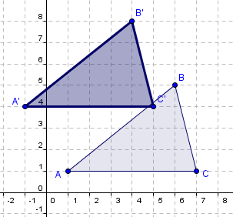
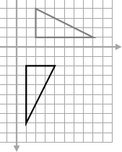
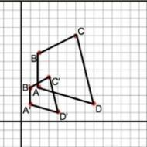
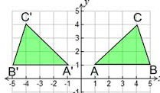
Identify the following transformations as a reflection, rotation, dilation, or translation.

5.
6.
7.
8.

Translate the following images:

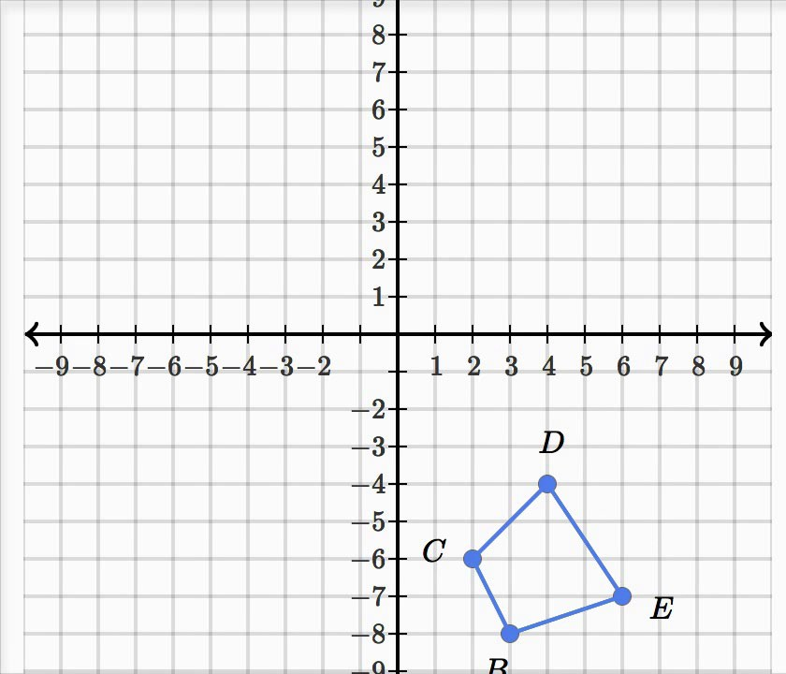
- Reflect over the X axis 10. Translate 4 to the left and 6 up.

Name Date

Write the translation rules in the space provided under each grid.

  - D’
E’
C A’
G’
  - D
C’ F’ E
B’ G

F

(x , y )
(x , y )

I J I’ J’

H K H’
M’
M
L’ N’
K’ L O’ N
O

(x , y )
(x , y )

Q

P R

Q’

P’ R’
S
T U

W
S’ V
T’ U’

W’
V’

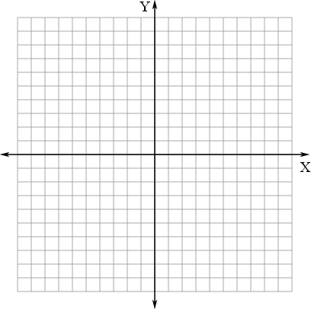

(x , y )
(x , y )

Name ANSWER KEY Date

Write the translation rules in the space provided under each grid.

- D’
E’
C A’
G’
- D
C’ F’ E
B’ G

F

(x + 6, y - 5)
(x - 3, y + 7)

I J I’ J’

H K H’
M’
M
L’ N’
K’ L O’ N
O

(x + 4 , y + 0)
(x + 3, y + 3)

Q

P R

Q’

P’ R’
S
T U

W
S’ V
T’ U’

W’
V’

(x + 0, y - 13)
(x - 8, y - 8)

Section 1: Lesson Preparation 3

Teacher Candidate Name:
Grade Level: | 8th
Date: | March 15, 2019
Unit/Subject: | Geometric Transformations
Instructional Plan Title: | Working with Congruent figures
Lesson Summary and Focus: | Students will begin the lesson with a guessing game to practice their recognition of the different transformations. Then they will learn more about congruency and practice picking out congruent figures.
Classroom and Student Factors/Grouping: | Preferential seating (see seating chart)  Extended time or shortened assignments (see assignment schedule) Group work (see grouping list and job chart)  Monitor students’ individual work frequently (see assignment schedule)
National/State Learning Standards: | Alabama Course of Study Mathematical Standard 8-G2  Understand that a two-dimensional figure is congruent to another if the second can be obtained from the first by a sequence of rotations, reflections, and translations; given two congruent figures, describe a sequence that exhibits the congruence between them

Specific Learning Target(s)/Objectives: | - Students will choose matching figures to identify congruent figures with at least 90% accuracy  - Students will differentiate between a translation, rotation and reflection by following instructions of different transformations with at least 90% accuracy  - Students will compare attributes of two-dimensional figures by answering discussion questions with 87% accuracy.
Academic Language | Students will participate in a guessing game that will require they ask questions using their vocabulary words. After this game the students will participate in a group discussion to determine what it means to have a congruent figure.  Transformation Reflection Rotation Translation Dilation Congruent Similar
Resources, Materials, Equipment, and Technology: | Radial Art Project Triangle Congruency Sort  Guess This! Transformation Graph paper  Rulers White board Markers

Section 2: Instructional Planning

Anticipatory Set  - Students will play the Guess This! Transformation game to give them more practice in recognizing the different transformations.  - I will explain the rules and provide a few example questions they could ask to help them figure out which transformation the other player chose.  - After the game, I will explain to the students that some of these transformations created congruent figures and some created similar figure. Today we are going to discuss congruent figures. | Time Needed
Multiple Means of Representation  - I will have students look over the sheet from the Guess This! Transformation game and we will figure out which of those are congruent figures. Through discussion, students will determine characteristics of what it means to be congruent.  - After this, I will have students pull out their graphic organizer or frayer model notes and make sure they have the information for congruent figures.  Explain how you will differentiate materials for each of the following groups:  - English language learners (ELL):  - Students with special needs:  Students will be monitored to ensure their notes are correct and they have the correct figures labeled as congruent.  - Students with gifted abilities:  - Early finishers (those students who finish early and may need additional resources/support): | Time Needed
Multiple Means of Engagement  - Students will use the information gained from the discussions so far to help them with the  Triangle Congruency Sort.  - I will choose one student to come and work one of the sorts on the board before they all do the sort on their own or with a partner.  Explain how you will differentiate activities for each of the following groups: | Time Needed

- English language learners (ELL):

- Students with special needs:
Students will be allowed to work with a partner or alone and use their notes.

- Students with gifted abilities:

- Early finishers (those students who finish early and may need additional resources/support):
Multiple Means of Expression  Students will be introduced to the unit assessment Radial Art Project that they will be given time to begin today but will not have to turn in till Monday. During the lesson today students will participate in a game called Guess This! Transformation that will provide a good indication of their knowledge thus far.  Explain if you will differentiate assessments for each of the following groups:  - English language learners (ELL):  - Students with special needs:  Students will be given plenty of time to work on this during class today and over the next few days. Also, they will be allowed their notes for referencing.  - Students with gifted abilities:  - Early finishers (those students who finish early and may need additional resources/support): | Time Needed

Extension Activity and/or Homework  Students can work on their art projects outside of class if they would like. | Time Needed
Rationale/Reflection
.
- Guess This! game promotes higher order thinking because it requires the students to think of their own questions to help them identify what the other player has chosen. It also promotes communication and collaboration.
- Graphic organizer or Frayer model promotes critical thinking and creativity. Students must infer the information they have to fill in on both.
- Think and share promotes critical thinking, communication and collaboration. When students use their notes or investigate the sheet to help them understand which figures are congruent, they are using critical thinking.

This project is a fun, creative, and real world way to incorporate geometric transformations. In this project student will began by making a rough draft of their art work on graph paper using step by step instructions. They will perform rotations, reflections, and translations. (You can also choose to include dilations). They can answer the questions pertaining to the transformations they made.
They will make a final draft of their artwork using a blank canvas or another sheet of graph paper. They can be graded in steps.

Radial Art Rough Draft: Name:

Step One: Number your graph paper and define each quadrant.

Step Two: In the first quadrant draw a rectangle placing it diagonal within the quadratic and label each coordinate. (Use a ruler). Name the shape ex: “big blue rectangle” and list the coordinates.

Quadrant 1
Shape Name: Coordinates
A:
B:
C:
D:

Step Three: In the second quadrant rotate the original shape from the first quadrants 90 degrees counterclockwise from the origin. Name the shape ex: “big blue rectangle quad 2” and list the coordinates.
Quadrant 2
Shape Name: Coordinates
A’:
B’:
C’:
D’:

Step Four: In the third quadrant rotate the rectangle from quadrant two 90 degrees counterclockwise from the origin. Name the shape ex: “big blue rectangle quad 3” and list the coordinates. Put them in prime prime notation (’’) since they were transformed twice from the original rectangle.

Quadrant 3
Shape Name: Coordinates
A’’:
B’’:
C’’:
D’’:
Step Five: In the fourth quadrant rotate the rectangle from quadrant three 90 degrees counterclockwise from the origin. Name the shape ex: “big blue rectangle quad 4” and list the coordinates. Put them in prime prime prime notation (’’’) since they were transformed three times from the original rectangle.

Quadrant 4
Shape Name: Coordinates
A’’’:
B’’’:
C’’’:
D’’’:

Step Six: Continue your art work in rotation by adding additional congruent lines and geometric shapes that are placed precisely in rotation and diagonally (at 90°) within each quadrant using coordinates as a guide. Alternate rotating counterclockwise and clockwise with each new shape you add. Make sure for each shape you start in the first quadrant. For each new shape: name your shape and record your coordinates. Tell which direction you are rotating.
The more shapes you put in your artwork the better it will come out☺

Rotation Questions:
- What similarities and differences did you see within your coordinates from quadrant one to quadrant
two?

- Rotating the rectangle in the second quadrant to the third quadrant by 90 degrees counterclockwise is the same as rotating the rectangle in the first

quadrant to the rectangle in the third quadrant counterclockwise by
degrees?
- What similarities and differences did you see within your coordinates from quadrant one to quadrant three?

- Rotating the rectangle in the third quadrant to the fourth quadrant by 90 degrees counterclockwise is the same as rotating the rectangle in the first quadrant to the rectangle in the fourth quadrant counterclockwise by
degrees?
- What similarities and differences did you see within your coordinates from quadrant one to quadrant four?

Step Seven: When your rotational/radial art work is completed. Come up with a unique name for your work and answer questions about reflections and translations.

- Name an example of a shape being reflected over the x axis. Compare and contrast there coordinates. What is similar? What is different?

.
- Name an example of a shape being reflected over the y axis. Compare and contrast there coordinates. What is similar? What is different?

.
- Name two examples of a shape being translated. What do you notice about their x values of the coordinates? What do you notice about the y values of the coordinates?

Students can do their final draft on a square canvas. Using a pencil you can have them lightly draw a coordinate plane and number it to help them plot their points. They will precisely plot out their points and use a ruler to draw their shapes.
Then can paint their artwork to their preference.

Directions: Cut apart all of the boxes and match each theorem with its definition. Next, sort the triangles into matching pairs. Then, decide whether or not each pair can be proven to be congruent based only on the given information. Place the pairs with the correct congruency theorem, or under the heading, “Can’t prove congruence.”
This will take a sheet of paper folded in half using a ‘hamburger’ fold and will be treated as a booklet. The ‘Can’t Prove Congruency’ heading will go at the top of the cover page, with the examples and definitions glued underneath of it. Glue the heading of Triangle Congruency at the top of each inside page. Glue 2 of the theorems on 1 page, on either side of the page, and the other 2 on the other page in the same manner. Glue the matching definitions and pairs of triangles underneath the correct theorems. The back of the booklet remains blank and is glued to the page in the notebook.
Headings for interactive notebook:
Triangle Congruency
Triangle Congruency

Angle, Angle, Side (AAS)

Angle, Angle, Angle (AAA)

Side, Angle, Side (SAS)

Angle, Side, Angle (ASA)

Can’t Prove Congruency

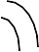
2 angles and their included side on 1 triangle are congruent to 2 angles and their included side on another triangle | Each side on 1 triangle congruent to a side on another triangle | 2 sides and their included angle on one triangle are congruent to 2 sides and their included angle on another triangle | 2 angles and a not included side on one triangle are congruent to 2 angles and a not included side on another triangle | 3 angles on 1 triangle are congruent to the 3 angles on another triangle

 | 36 cm. | 18 | cm. | 24cm. | 39º | 51º  63º |  |  | 72º  21 in.  19 in.
24 cm. 18cm.  36cm. | 63º |  | 51º |  | 65º  14 cm.  47º |  |  |  | 12 cm.  16 cm. 14 cm.
10 in. | 39º |  |  |  | 12 cm.  16 cm. 14 cm. | 54º  8 cm. |  |  | 2 sides and a not included angle on 1 triangle  congruent to 2 sides and a not included angle on another triangle
65º
14 cm. | 8 cm. |  |  |  | 10 in. | 19 in.
47º |  | 54º |  |  |  |  | 21 in. | 72º

Standards-Based Rubric Geometric Transformation Unit

Standards Based Criteria | Doesn’t Meet Standard (1) | Partially Meets Standard (2) | Meets Standard (3) | Exceeds Standard (4)
16 ) Verify experimentally the properties of rotations, reflections, and translations: [8- G1]  - Lines are taken to lines, and line segments are taken to line segments of the same length.  [8-G1a]  - Angles are taken to angles of the same measure. [8-G1b]  - Parallel lines are taken to parallel lines. [8-G1c] | Not addressed | Students can label examples of translation, rotation and reflection. | Through the use of various geometric construction models and the manipulation of said models, students reason general properties of translations, rotations and reflections. | Students create various geometric construction models and manipulate them to show examples of translation, rotation and reflection.
17 ) Understand that a two- dimensional figure is congruent to another if the second can be obtained from the first by a sequence of rotations, reflections, and translations; given two congruent figures, describe a sequence that | Not addressed | Student identifies two congruent 2-D shapes but does not give proof. Or student gives correct steps of sequence but the shapes are not congruent. | Using a variety of 2-D shapes, students identify and prove two shapes are congruent by showing the sequence it takes to map one object to the other through translation, rotation and reflection. | Student creates two 2-D shapes that are congruent and gives proof by providing the sequence he or she followed to map one object to the other using translation, rotation and reflection.

exhibits the congruence between them. [8- G2]
18 ) Describe the effect of dilations, translations, rotations, and reflections on two- dimensional figures using coordinates. [8- G3] | Not addressed | Student can label examples of translations, rotations, reflections and dilations on 2-D figures on a coordinate plan. | Through the use of a coordinate plane, students will model and describe the effects of geometric transformation sequences on a given shape and its | Using a coordinate plane, students will create a 2-D shape and perform and describe geometric transformation sequences and then compare the new figure to the
 |  |  | coordinates. | original to
 |  |  | Through | determine if it is
 |  |  | comparison of the | congruent or
 |  |  | new and original | similar.
 |  |  | figure, students
 |  |  | will determine if
 |  |  | they are congruent
 |  |  | or similar.
19 ) Understand | Not addressed | Student identifies two similar 2-D shapes but does not give proof. Or student gives correct steps of sequence but the shapes are not similar. | Using a variety of 2-D shapes, students will identify and prove two shapes are similar by showing the sequence it takes to map one object to the other through translation, rotation, reflection and dilation. | Student creates two 2-D shapes that are similar and gives proof by providing the sequence he or she followed to map one object to the other using translation, rotation, reflection and dilation.
that a two-
dimensional figure
is similar to
another if the
second can be
obtained from the
first by a sequence
of rotations,
reflections,
translations, and
dilations; given
two similar two-
dimensional
figures, describe a
sequence that
exhibits the
similarity between
them. [8-G4]

Divide Student’s Score by Total Possible Points: / =

