Compton ELA… Straight Outa’

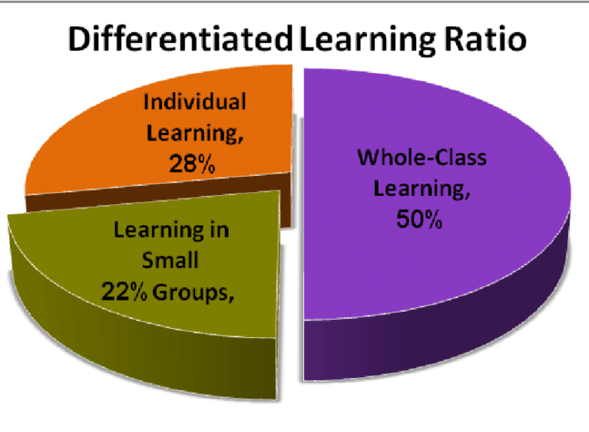

Create a 500-750 word blog post for teachers in which you provide creative suggestions for assessment strategies and use of data in your content area.
Include the following:
- Describe the different uses of formative and summative assessment methods in your content area .
- Provide two creative assessment strategies for your content area that allow students to demonstrate their knowledge and skills in multiple ways.
- Provide a brief explanation on how teachers can determine student mastery of content in your area using the described assessment strategies.
While APA format is not required for the body of this assignment, solid academic writing is expected, and in-text citations and references should be presented using APA documentation guidelines.

Renee,

Thank you for your blog post on assessments to provide creative suggestions for English teachers. You did a great job to keep the attention of your readers. I especially liked your clip art and format as you explained assessments with the inclusion of varied strategies to determine mastery of content. To avoid the paper/pencil tests, I liked the Web quests, Foldable, Share-Pair-Compare, Wordle.net, Jig-Saw along with the tiered assignment. Many of your assessment strategies address kinesthetic and artistic learning styles which can be a culmination of any unit plan.
I didn’t want to mess up your blog as it was so very well done and formatted so nicely. I am wondering if I can use your paper as an example for week 2. You did such a good job actually speaking to other English teachers. Rather as an assignment for me. Of course for privacy I can make sure your name is not shown.

Here are some English Teacher Blogs you may be interested in joining.
https://blog.feedspot.com/english_teacher_blogs/
https://secondaryenglishcoffeeshop.blogspot.com/

Cindy

Assessments
Summative
formal, a manner in which an evaluator chooses from a various methods at the end of the unit/lesson to determine (evaluate)what their subjects have learned overall.

Formative
informal, a manner in which an evaluator knows where their subjects are in learning and understanding the content through various activities completed and incorporated throughout the lesson. (Strengths, weakness, review needed)

Examples of assessments that can be fun as well as useful may include and engage students are Web quests, Foldable, Share-Pair-Compare, Wordle.net, Jig-Saw, It stuck to me, Bell Ringers, Journals, Predictions and share-outs, Thumbs Up, Cube-it, and small creative projects.

Always remember student choice is important, therefore having options to choose from is a successful way to engage and see a student’s strength. Scaffold- Create Learning Mats. ELL- Bi-Lingual written/recorded passages/texts/ assignments available. Tools, resources and wheels have already been created- look to borrow them.

If at the beginning of a unit when going over the syllabus/expectations along with the objectives have a sheet with possible options for a final assessment. This tool may allow students to think about how they want to approach the unit with you. Will the students want more graphic organizers? More peer lead collaborative discussions with Jig-Sawing? Cornell note taking. Remember giving students a voice in learning not only engages them, but also allows you to utilize the vast possibilities in the tools and strategies. A rubric with set standards and expectations of understanding will allow students to know what will complete an assignment from zero to one hundred.

Students then are able to show their understanding and knowledge gained at the completion of the unit by creating a video or another form of media demonstrating the literary elements and devices as related to the topic/ novel read. There is the traditional paper and pencil test, but no one enjoys these, therefore twist it up.

English Language Arts Friends: Have you tried a Tiered Assignment? In preparing for a recent reading of Macbeth, creating a plan of interest and engagement for students can be challenging. Setting the learning platform, expectations, giving choices with an overall agenda may help. What approach to take- read it only…. Boring!!!

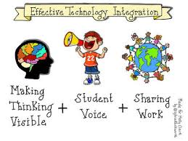
Why not let the students choose their final project to complete before you begin reading (as a whole group large and small; audio listen and follow) Macbeth? Why, do you ask? By having a student choose, the manner in which they have a vision of their final project will formulate the manner to which their focus on strategies used to learn and demonstrate will be. Will the student use graphic organizers to compare and contrast characters? How will the student differentiate between the characters- characterization chart? What elements and devises are important and relevant to their final project? What lessons will assist in the learning of Macbeth, Cornell Notes, Foldable, and Gallery Walk, technology game of Jeopardy or Kahoot to review? Opportunities are endless in the learning strategies and teaching methods, but what possibilities were the students able to generate as final projects- T.V commercial, Movie Poster/Trailer, Game Show, news report, or another activity.

So the next time you are preparing a lesson for a unit- stop, drop, and think of the alternatives to the paper and pencil or look and listen. English is such a wonderfully confusing language with many interesting attributes to learn more about!

References:
Blau, Ina. (2011). Teachers for "Smart Classrooms": The Extent of Implementation of an Interactive Whiteboard-based Professional Development Program on Elementary Teachers' Instructional Practices. Interdisciplinary Journal of e-Skills and Lifelong Learning. 7. 275-289. 10.28945/1524.

Rock Paper Scissors- 5"x7" Unframed Art Print by Jamie Rice
Royalty-free stock vector ID: 1397861801

Small characters asking questions around a huge question mark. flat design style minimal vector illustration by Mimiwide Shutterstock retrieved from https://www.shutterstock.com/image-vector/small-characters-asking-questions-around-huge-1397861801

From Vision to Reality: A Walk of Faith Kindle Edition by Yolonda Berry

Rutherford, Paula. Meeting the Needs of Diverse Learners, 2010, Just ask Publications Alexandria Virgina

